**Project Design Phase**

**Solution Architecture**

|  |  |
| --- | --- |
| Date | 05 July 2025 |
| Team ID | LTVIP2025TMID35592 |
| Project Name | EduTutor AI: Personalized Learning With Generative AI And LMS Integration |
| Maximum Marks | 4 Marks |

**Solution Architecture:**

Edututor Ai is built on a modular, cloud-native, and API-first architecture that intelligently enhances each stage of the learning lifecycle. It starts with multi-channel user inputs—such as lesson plans, student data, or natural language prompts—which are processed through an AI-driven engine to extract learning objectives and personalization needs. These inputs flow into a generative AI core that creates adaptive content, quizzes, and real-time feedback loops. The output is seamlessly delivered via LMS platforms, mobile apps, or dashboards, while all interactions contribute to a centralized intelligence layer for continuous learning optimization. Its scalable, plug-and-play design ensures easy integration across educational environments and diverse learner groups.

**Example - Solution Architecture Diagram:**

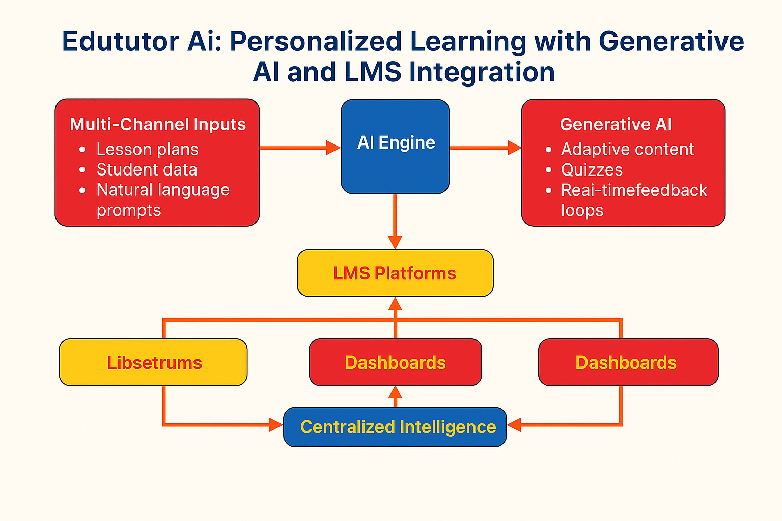

**Reference: 🔗** [**https://www.educause.edu/initiatives/generative-ai**](https://www.educause.edu/initiatives/generative-ai)

**📘 Edututor Ai – Architecture Summary:**

Edututor Ai is architected as a modular, AI-first platform that intelligently enhances the entire personalized learning lifecycle. It begins by capturing inputs from multiple channels—such as learner data, educator prompts, LMS interactions, or file uploads—making it accessible to both instructors and students across disciplines. These inputs flow into a robust AI analysis layer that extracts learning goals, performance patterns, and personalization signals using advanced natural language and data interpretation models.

Once structured, the data is handed off to an intelligent orchestration engine that manages various educational tasks: generating tailored lesson plans and quizzes; offering contextual feedback; adapting instructional pace; and recommending learning pathways in real time. This system supports flexible and dynamic workflows based on learner progress and engagement.

A real-time collaboration layer enables instructors to review, customize, and refine AI-generated materials collaboratively. It includes integrated LMS modules, adaptive content editors, and role-based dashboards. Outputs are delivered through familiar platforms—such as Moodle, Canvas, or custom portals—ensuring seamless integration within existing educational ecosystems.

Importantly, every interaction is logged into a central insight and feedback layer that continuously refines AI performance using learning analytics, educator input, and learner outcomes. The full stack is scalable, API-driven, and deployable across cloud, on-prem, or hybrid setups—ensuring pedagogical flexibility, system resilience, and institutional scalability.

Instructors benefit from a streamlined teaching workflow supported by Edututor Ai’s intuitive user experience. Through intelligent suggestion engines, educators receive real-time recommendations for content pacing, formative assessment triggers, and at-risk student alerts—empowering proactive decision-making. The platform not only augments the teacher’s capacity but also reinforces their role as facilitator and mentor, rather than content producer and grader. Built-in customization options allow educators to fine-tune generative outputs to match curriculum standards, local regulations, and diverse learner profiles.

From the learner’s perspective, the system provides a deeply personalized journey that dynamically evolves based on interaction patterns, comprehension levels, and feedback loops. Students receive content tailored to their learning styles—whether visual, auditory, or kinesthetic—and benefit from adaptive quizzes, immediate feedback, and on-demand explanations powered by generative AI. This one-on-one digital mentorship fosters stronger engagement, increased motivation, and measurable academic gains.

